
SERANGOON JUNIOR COLLEGE
General Certificate of Education Advanced Level
Higher 2

CHEMISTRY 9647/01, 9746/01
JC2 Preliminary Examination 25 Aug 2010
Paper 1 MCQ 1 hour

Additional Materials: OMS
Data Booklet

READ THESE INSTRUCTIONS FIRST

Write in soft pencil.
Do not use staples, paper clips, highlighters, glue or correction fluid on the OMS.

Follow the instructions given to you on how to fill in the OMS.
Write your name and index number on the OMS in the spaces provided.
Shade correctly the item index number, starting with the number “2” and the last 4 numbers of your FIN/NRIC number.
Eg. If your NRIC is S8906660Z, shade 26660 for the item index number.

There are forty questions on this paper. Answer all questions. For each question there are four possible answers A, B, C and D.
Choose the one you consider correct and record your choice in soft pencil on the separate OMS

Each correct answer will score one mark. A mark will not be deducted for a wrong answer.
Any rough working should be done in this booklet.

This document consists of 18 printed pages and 0 blank page
Answer ALL Questions

1 | 50 cm³ of a 0.10 mol dm⁻³ solution of a metallic salt was found to react exactly with 25.0 cm³ of 0.10 mol dm⁻³ aqueous sodium sulfite. In this reaction, the sulfite ion is oxidised as follows:  SO₃²⁻ (aq) + H₂O (l) → SO₄²⁻ (aq) + 2H⁺ (aq) + 2e  What is the new oxidation number of the metal in the salt if its original oxidation number was +3?
 | A | +1
 | B | +2
 | C | +4
 | D | +5

2 | When methane, CH₄, was burned in an incorrectly adjusted burner, it was converted into a mixture of carbon dioxide and carbon monoxide in the ratio 99:1, together with water vapour.  What is the volume of oxygen consumed when y dm³ of methane is burned?
 | A | ( y – 0.01y) dm³
 | B | 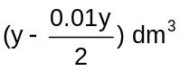
 | C | ( 2y – 0.01y ) dm³
 | D | 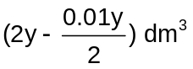

3 | In an experiment, a sample of Americium element (Am) was vaporised, ionised and passed through an electric field. Analysis revealed that a beam of ²⁴¹Am⁺ gives an angle of deflection of 2 º.  What would be the angle of deflection for a sample of singly charged calcium ions?
 | A | 12.0 º
 | B | 6.0 º
 | C | 2.0 º
 | D | 0.3 º

4 | Two elements A and B have the following properties:  - A and B form ionic compounds Na₂A and Na₂B respectively.  - Element B forms BF₆ molecule whereas A is not able to do so.  Which of the following pairs of electronic configuration for A and B is correct?
 |  | A B
 | A | [He] 2s² 2p⁴ [He] 2s² 2p²
 | B | [He] 2s² 2p² [He] 2s² 2p⁶ 3s² 3p³
 | C | [He] 2s² 2p² [He] 2s² 2p⁶ 3s² 3p²
 | D | [He] 2s² 2p⁴ [He] 2s² 2p⁶ 3s² 3p⁴

5 | The ideal gas equation for n mol of gas is PV = nRT.  A graph of 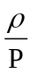verses P is obtained for a real gas C where 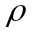= density of gas in g dm⁻³  and P = pressure of gas in atm.  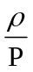  Y  P  At P = 0 atm and T = 273K, the relative molecular mass of C is
 | A | 273RY
 | B | 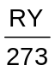
 | C | 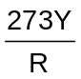
 | D | 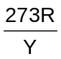

6 | A 2 g sample of hydrogen at temperature T and of volume V exerts a pressure P.  Deuterium, 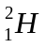 is an isotope of hydrogen.  Which of the following would also exert a pressure of P at the same temperature T?
 | A | A mixture of 2 g of hydrogen and 2 g of deuterium of total volume 2V.
 | B | A mixture of 1 g of hydrogen and 2 g of deuterium of total volume 2V.
 | C | A mixture of 1 g of hydrogen and 2 g of deuterium of total volume V.
 | D | A mixture of 1 g of hydrogen and 1 g of deuterium of total volume V.

7 | Which one of the following statements best explains why the boiling point of butanone (79.6 ºC) is higher than that of pentane (36.1 ºC)?
 | A | The relative molecular mass of butanone is higher than that of pentane.
 | B | The butanone molecule has a larger surface area than the pentane molecule.
 | C | The covalent bonds in butanone molecules are stronger than those in the pentane molecules.
 | D | There are stronger dipole interactions between butanone molecules but only weak interactions between pentane molecules.

8 | Which of the following statements about the structures of graphite and diamond is correct?
 | A | Graphite has a shorter carbon-carbon bond length due to the overlap of sp² orbitals.
 | B | Diamond has a shorter carbon-carbon bond length due to the overlap of sp² orbitals.
 | C | All covalent bonds in diamond are of the same length but those in graphite are not.
 | D | The C-C-C bond angle is larger in diamond than in graphite.

9 | The distribution of the fraction of molecules with energy for two temperatures, T₁ and T₂ are shown in the diagram below.  D, F and G refer to the different shaded areas under the two graphs.  T₂  T₁  Fraction of molecules with energy, E  T₁ < T₂  E_{a} = Activation Energy  Energy  E_{a}  D  G  F
 | Which expression gives the fraction of molecules having at least the activation energy at higher temperature, T₂?
 | A | 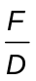
 | B | 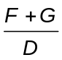
 | C | 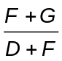
 | D | 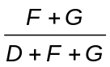

10 | Consider the following equilibrium system:  Fe₃O₄(s) + CO(g) CO₂(g) + 3 FeO(s)  It is a slightly endothermic reaction at room temperature.  Which of the following changes is correct?
 | A | Decreasing the temperature causes the position of equilibrium to shift to the left.
 | B | Increasing pressure of CO(g) causes the position of equilibrium to shift to the left.
 | C | Adding Fe₃O₄(s) causes the position of equilibrium to shift to the right.
 | D | Reducing [CO₂(g)] causes the position of equilibrium to shift to the left.

11 | What is the pH of a solution formed by mixing 0.45 g of lactic acid and 0.84 g of sodium lactate in a 500 cm³ beaker?  (Given K_{a} of lactic acid = 1.34 x 10⁻⁴ mol dm⁻³, M_{r} of lactic acid = 90, M_{r} of sodium lactate = 112)
 | A | 3.60
 | B | 3.70
 | C | 3.87
 | D | 4.05

12 | Which graphs below correctly represents how ΔG varies with temperature for the combustion of octane?
 | A  ΔG / kJ mol^{–1} | T / K
 | B  ΔG / kJ mol^{–1} | T / K
 | C  ΔG / kJ mol^{–1} | T / K
 | D  ΔG / kJ mol^{–1} | T / K
13 | When the switch in the circuit shown below is closed, a steady current of 5 A is passed through the electrolyte for 32 min at s.t.p.  Which statement is incorrect?  Bronze anode (an alloy of copper and tin)  switch  100 cm³ of 0.1 mol dm^{–3} dilute sulphuric acid  platinum cathode
 | A | The anode becomes silvery in colour.
 | B | About 1.11 dm³ of gas will be collected at the cathode.
 | C | A straight line graph showing mass of the anode decreasing with time can be obtained.
 | D | Litmus solution turns blue when added around the cathode.

14 | Element S forms a chloride which dissolves in water to give an acidic solution. It also forms an oxide which dissolves readily in acids.  What could S be?
 | A | Calcium
 | B | Aluminium
 | C | Silicon
 | D | Phosphorus

15 | The use of Data Booklet is relevant for this question.  The graph below shows the second ionisation energies of four elements, numbered 1 to 4.  The elements are adjacent to each other in the Periodic Table.  Second ionisation energy (arbitrary units)  Atomic number  1  2  3  4  Which statement about the elements 1 to 4 is incorrect?
 | A | The melting point of the elements increases in the order of 1 < 2 < 3 < 4
 | B | The atomic radius of the elements decreases in the order of 2 > 3 > 4 > 1
 | C | The third ionisation energy of the elements decreases in the order of 3 > 2 > 1 > 4
 | D | The covalent character of the chlorides of the elements increases in the order 1 > 2 > 3 > 4

16 | Which of the following is NOT true about Group II compounds?
 | A | Solubility of Group II sulfates increases down the group.
 | B | Calcium nitrate decomposes on heating to give the corresponding oxide, NO₂ gas and O₂ gas.
 | C | Reactivity of Group II oxides with water increases down the group.
 | D | Lattice energy of Group II oxides becomes less exothermic down the group.

17 | Group II carbonates decompose according to the following equation:  MCO₃ (s) → MO (s) + CO₂ (g)  Which of the following factor helps to explain this trend?
  Element | Mg | Ca | Sr | Ba
  ∆H/ kJ mol⁻¹ | +101 | +178 | +235 | +269
 | A | The electronegativity of the elements decreases down the group.
 | B | The reducing power of the elements increases down the group.
 | C | The ionic radius increases down the group.
 | D | The relative formula mass of the carbonate increases down the group.

18 | Which of the following statements is true about hydrogen halides?
 | A | Enthalpy change of formation becomes less exothermic down the group.
 | B | Thermal stability increases down the group.
 | C | Acidity of the corresponding aqueous solution decreases down the group.
 | D | Charge density of cation decreases down the group.

19 | Astatine is below iodine in Group VII.  Which of the following would be a correct prediction for astatine and its compounds?
 | A | Astatine would oxidise chloride to chlorine.
 | B | Potassium astatide would be a white crystalline solid.
 | C | Astatine is insoluble in chloroform.
 | D | Silver astatide reacts with concentrated aqueous ammonia to form a soluble complex.

20 | Chromium (III) chloride combines with ammonia to form compound T in which the coordination number of chromium is 6. When solution T is treated with an excess aqueous silver nitrate, only one third of the total chloride present is precipitated as AgCl.  What is the formula of compound T?
 | A | Cr(NH₃)₃Cl₃
 | B | Cr(NH₃)₄Cl₃
 | C | Cr(NH₃)₅Cl₃
 | D | Cr(NH₃)₆Cl₃

21 | The structure of Ergocalciferol, also known as vitamin D₂ is shown below:  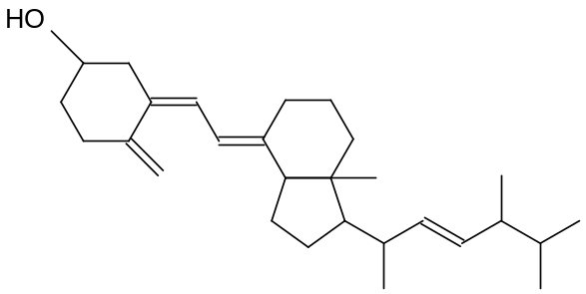  Ergocalciferol  How many optical isomers are present in this molecule?
 | A | 6
 | B | 8
 | C | 12
 | D | 64

22 | Which of the following is NOT the product formed when butene reacts with IBr (aq)?
 | A | 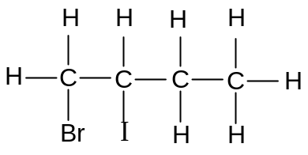
 | B | 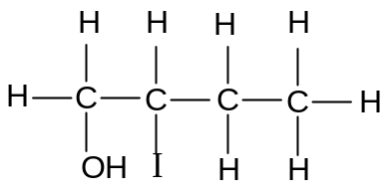
 | C | 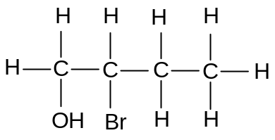
 | D | 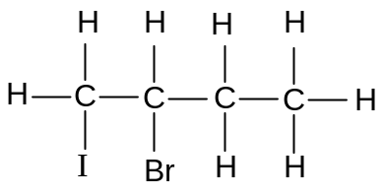

23 | Pyrogallol is a powerful reducing agent that is used to remove oxygen. When 15 cm³ of a gaseous hydrocarbon is combusted with 180 cm³ of oxygen, there was a contraction of 52.5 cm³. On further treatment with pyrogallol, there was a reduction of 82.5 cm³.  What is the molecular formula of the hydrocarbon?  (All volumes are measured at room temperature and pressure.)
 | A | C₃H₈
 | B | C₄H₈
 | C | C₄H₁₀
 | D | C₅H₁₀

24 | When hot NaOH is added to compounds H and J, C₆H₅CH₂OH and C₆H₅CH=CH₂ are formed respectively. What could compounds H and J be?
 |  | H | J
 | A | 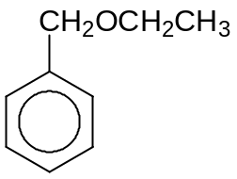 | 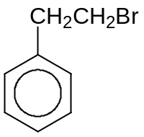
 | B | 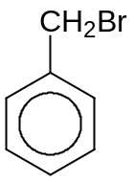
 | C |  | 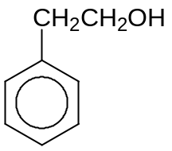
 | D

25 | Which one of the following will be formed when butane-1,3-diol is distilled with hot alkaline potassium manganate (VII)?
 | A | CH₃COCH₂CHO
 | B | CH₃COCH₂COOH
 | C | CH₃CH(OH)CH₂COO–
 | D | CH₃COCH₂COO–

26 | The following reagents were added to K and M and the observations were made:  What could be the structural formulae of K and M?
  Reagents | Observation
  Alkaline aqueous iodine | Brown iodine decolourises for K but not M
  Acidified potassium dichromate (VI) | Green solution seen for K but not M
  Aqueous bromine | M decolourise reddish brown bromine but not K
 |  | K | M
 | A | 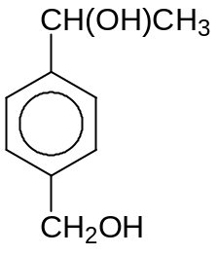 | 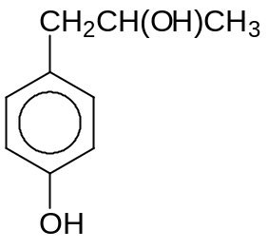
 | B | 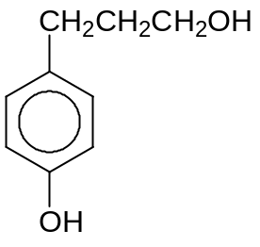 | 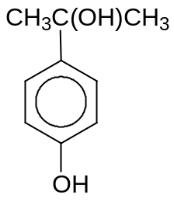
 | C
 | D

27 | Compounds N and P are first reacted with hot aqueous NaOH followed by dilute HCl at room temperature.  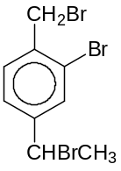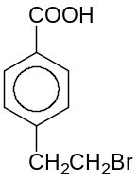  Compound N Compound P  Which reagents could be used to distinguish the final products of N and P?
 | A | H₂, Ni catalyst
 | B | Iodine in aqueous NaOH
 | C | Phosphorus pentachloride
 | D | Na metal

28 | Compound Q can be converted to compound R in a sequence of steps.  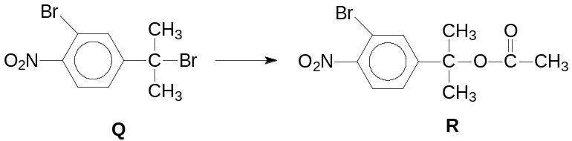  Which of the following statements is correct?
 | A | The sequential conversion of Q to R involves a nucleophilic substitution reaction, acidic hydrolysis and esterification.
 | B | Compound Q must be converted into an alkene first in the first step of conversion to compound R.
 | C | Neutralisation occurs when aqueous sulfuric acid is added to Q and R separately at rtp.
 | D | When hot aqueous sodium hydroxide is added separately to compounds Q and R, only compound Q gives a cream precipitate when added to silver nitrate solution.

29 | Which procedure gives the best yield of phenylbenzoate, C₆H₅CO₂C₆H₅?
 | A | Reacting C₆H₅CO₂H with SOCl₂, then adding C₆H₅OH.
 | B | Reacting C₆H₅OH with NaOH, then adding C₆H₅COCl.
 | C | Refluxing a mixture C₆H₅CO₂H and C₆H₅OH with concentrated H₂SO₄.
 | D | Reacting C₆H₅OH with SOCl₂, then adding C₆H₅CO₂H.

30 | Consider the following four compounds:  What is the relative order of decreasing basicity of these compounds?
  1 | phenylamine
  2 | 2-bromopropylamine
  3 | 3-chloropropanamide
  4 | propylamine
 | A | 3 | 2 | 4 | 1
 | B | 2 | 4 | 1 | 3
 | C | 4 | 2 | 1 | 3
 | D | 2 | 3 | 4 | 1

For questions 31 – 40, one or more of the numbered statements 1 to 3 may be correct. Decide whether each of the statements is or is not correct. The responses A to D should be selected on the basis of
A | B | C | D
1, 2 and 3  are correct | 1 and 2 only  are correct | 2 and 3 only  are correct | 1 only  is correct

No other combination of statements is to be used.
31 | Which of the following contain(s) hydrogen bonds?
 | 1 | NH₄Cl (s)
 | 2 | NH₃ (l)
 | 3 | HNO₃ (l)

32 | Bromine and methanoic acid react as follows:  Br₂ (aq) + HCO₂H (aq) → 2Br⁻ (aq) + 2H⁺ (aq) + CO₂ (g)  The order of reaction with respect to bromine and methanoic acid are found to be one respectively.  Which of the following statement(s) is / are correct?
 | 1 | Doubling the concentration of methanoic acid doubles the rate of evolution of gas.
 | 2 | Halving the concentration of both reactants simultaneously will halve the reaction.
 | 3 | The overall order of reaction is one.

A | B | C | D
1, 2 and 3  are correct | 1 and 2 only  are correct | 2 and 3 only  are correct | 1 only  is correct

33 | For the reaction: N₂O₄(g) 2NO₂(g)  the numerical values of K_{p} at two different temperatures are given as follows:  Which of the following statement(s) is / are correct?
  Temperature/ K | K_{p}
  500 | 1.70 x 10³
  600 | 1.78 x 10⁴
 | 1 | The proportion of NO₂ in the equilibrium mixture is increased by decreasing the pressure.
 | 2 | The standard enthalpy change of the forward reaction is negative.
 | 3 | The units for K_{p} are atm⁻¹.

34 | In an acid-base titration, 25.0 cm³ of 0.150 mol dm⁻³ HCl was titrated with 0.150 mol dm⁻³ NH₃. The table below shows the data of four acid-base indicators.  Which of the following show(s) the correct indicator used with their corresponding colour observed in the above titration?
  Indicator | Approximate pH range | Colour change
  Indicator | Approximate pH range | In acid | In alkali
  Congo red | 3.0 – 5.0 | Blue-violet | Red
  Bromocresol green | 3.8 – 5.5 | Yellow | Blue
  Cresol red | 7.2 – 8.8 | Yellow | Reddish – purple
 |  | Indicator Colour at end-point
 | 1 | Congo red violet
 | 2 | Bromocresol green green
 | 3 | Cresol red orange
.
35 | Which of the following statement(s) regarding alkyl halides is/are true?
 | 1 | Chlorofluorocarbons are suitable to be used as aerosol because it does not react with the compounds that it is carrying and it is very volatile.
 | 2 | Chlorofluorocarbons are non-biodegradable because they are chemically inert.
 | 3 | Chlorofluorocarbons slowly diffuse towards the upper atmosphere where they are cleaved into fluorine radicals by UV light.

A | B | C | D
1, 2 and 3  are correct | 1 and 2 only  are correct | 2 and 3 only  are correct | 1 only  is correct

36 | Which of the following statement(s) is / are true when the compound below reacts with hot aqueous H⁺?  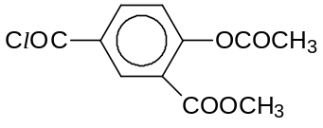
 | 1 | White fumes are observed.
 | 2 | A white precipitate is observed.
 | 3 | Hydrolysis has taken place.

37 | Haemoglobin is the iron-containing oxygen-transport metalloprotein found in the red blood cells of vertebrates and the tissues of some invertebrates.  The following fragments were obtained after hydrolysis of a typical haemoglobin molecule:  leu  his-leu-thr  pro-glu  thr-pro  Which statement(s) is / are correct?
 | 1 | The form H₃N⁺CHRCO₂– is the most common species for any amino acids at pH=7
 | 2 | The fragments may be obtained when haemoglobin is heated in 6 mol dm⁻³ NaOH(aq).
 | 3 | The sequence of the haemoglobin chain should be -his-leu-thr-pro-glu-.

38 | Use of the Data Booklet is relevant to this question.  The exhaust systems of most new cars are fitted with catalytic converters that contain transition metals as catalysts to decrease the emission of atmospheric pollutants. Platinum and palladium are the two most common elements used.  Which of the following statement(s) is/are correct?
 | 1 | Palladium and platinum can exist in variable oxidation states.
 | 2 | Palladium and platinum have similar atomic radii.
 | 3 | On addition of lead to the catalytic convertor the rate of removal of oxides of nitrogen will be accelerated.

A | B | C | D
1, 2 and 3  are correct | 1 and 2 only  are correct | 2 and 3 only  are correct | 1 only  is correct

39 | When iron filings are added to nitric acid, a brown gas is formed. On the addition of ammonium thiocyanate, a blood red colouration due to an iron (III) complex is formed.  Which statement (s) is / are correct?
 | 1 | Iron acts as a reducing agent.
 | 2 | The standard cell potential of the reaction between iron filings and nitric acid is +0.85V.
 | 3 | Addition of potassium cyanide into the reaction between iron filings and nitric acid will result in an increase in the standard cell potential.

40 | An element X has the electronic configuration [Ar]3d³4s² and forms a series of oxo-compound.  Which of the following species of X are likely to be formed?
 | 1 | XO₂⁺ and XO₃
 | 2 | XO₃⁻ and XCl₃
 | 3 | XO²⁺ and XO₃²⁻

-END OF PAPER-

